Lab 5A: Basic RIPv2 Configuration

# Topology Diagram

**Addressing Table**

|  |  |  |  |  |
| --- | --- | --- | --- | --- |
| **Device** | **Interface** | **IP Address** | **Subnet Mask** | **Default Gateway** |
| **R1** | **Fa0/0** | 192.168.1.1 | 255.255.255.0 | N/A |
| **S0/0/0** | 192.168.2.1 | 255.255.255.0 | N/A |
| **R2** | **Fa0/0** | 192.168.3.1 | 255.255.255.0 | N/A |
| **S0/0/0** | 192.168.2.2 | 255.255.255.0 | N/A |
| **S0/0/1** | 192.168.4.2 | 255.255.255.0 | N/A |
| **R3** | **Fa0/0** | 192.168.5.1 | 255.255.255.0 | N/A |
| **S0/0/1** | 192.168.4.1 | 255.255.255.0 | N/A |
| **PC1** | **NIC** | 192.168.1.10 | 255.255.255.0 | 192.168.1.1 |
| **PC2** | **NIC** | 192.168.3.10 | 255.255.255.0 | 192.168.3.1 |
| **PC3** | **NIC** | 192.168.5.10 | 255.255.255.0 | 192.168.5.1 |

### Task 1 – 25 points

### Step 1: Add the logging synchronous command to the console and virtual terminal lines

This command is very helpful in both lab and production environments and uses the following syntax:

Router(config-line)# line console 0

Router(config-line)#**logging synchronous**

Router(config-line)# line vty 0 4

Router(config-line)#**logging synchronous**

### Step 2: Disable DNS lookup

Router(config)#**no ip domain-lookup**

### Step 3: Configure the interfaces on R1, R2, and R3

Configure the interfaces on the R1, R2, and R3 routers with the IP addresses from the table under the Topology Diagram.

### Step 4: Verify IP addressing and interfaces

Use the **show ip interface brief** command to verify that the IP addressing is correct and that the interfaces are active.

### Step 5: Configure Ethernet interfaces of PC1, PC2, and PC3

Configure the Ethernet interfaces of PC1, PC2, and PC3 with the IP addresses and default gateways from the table under the Topology Diagram.

### Step 6: Test the PC configuration by pinging the default gateway from the PC

**Task: Configure RIP**

**Step 1: Enable dynamic routing**

To enable a dynamic routing protocol, enter global configuration mode and use the **router** command.

Enter **router ?** at the global configuration prompt to a see a list of available routing protocols on your router.

To enable RIP, enter the command **router rip** in global configuration mode.

Router(config)#**router rip**

Router(config)#version 2

### Task 2: Enter classful network addresses – 25points

Once you are in routing configuration mode, enter the classful network address **for each directly connected network**, using the **network** command with the following syntax:

Router(config-router)#**network <network_nr>**

The **network** command:

* Enables RIPv2 on all interfaces that belong to this network. These interfaces will now both send and receive RIP updates.
* Advertises this network in RIP routing updates sent to other routers every 30 seconds.

**Task: Verify RIP Routing**

### Step 1: Use the show ip route command to verify that each router has all of the networks in the topology entered in the routing table

Routes learned through RIP are coded with an **R** in the routing table.

### Step 2: Use the show ip protocols command to view information about the routing processes

The **show ip protocols** command can be used to view information about the routing processes that are occurring on the router. This output can be used to verify most RIP parameters to confirm that:

* RIP routing is configured
* The correct interfaces send and receive RIP updates
* The router advertises the correct networks
* RIP neighbors are sending updates

### Step 3: Use the no auto-summary to turn off automatic summarization in RIPv2. Disable auto summarization on all routers. The routers will no longer summarize routes at major network boundaries

### R2(config)#router rip

### R2(config-router)#no auto-summary

### Step 4: Use the debug ip rip command to view the RIP messages being sent and received

Ripv2 updates are sent every 30 seconds on multicast IP address 224.0.0.9 so you may have to wait for debug information to be displayed.

For example:

### R1#debug ip rip

R1#RIP: received v1 update from 192.168.2.2 on Serial0/0/0 192.168.3.0 in 1 hops

192.168.4.0 in 1 hops

192.168.5.0 in 2 hops

RIP: sending v1 update to 255.255.255.255 via FastEthernet0/0 (192.168.1.1)

RIP: build update entries

network 192.168.2.0 metric 1

network 192.168.3.0 metric 2

network 192.168.4.0 metric 2

network 192.168.5.0 metric 3

RIP: sending v1 update to 255.255.255.255 via Serial0/0/0 (192.168.2.1)

RIP: build update entries

network 192.168.1.0 metric 1

The debug output shows that R1 receives an update from R2. Notice how this update includes all the networks that R1 does not already have in its routing table. Because the FastEthernet0/0 interface belongs to the 192.168.1.0 network configured under RIP, R1 builds an update to send out that interface. The update includes all networks known to R1 except the network of the interface. Finally, R1 builds an update to send to R2. Because of split horizon, R1 only includes the 192.168.1.0 network in the update.

### Step 4: Discontinue the debug output with the undebug all command

R1#**undebug all**

All possible debugging has been turned off

### Step 5: Show only RIP statements in the routing table

1. Enter **show ip route rip** command
2. What is the administrative distance of RIP? 120

### Step 6: Last route update

1. Check the routing table for a specific route (IOS version must be at least 12.x)

For example: Enter **show ip route 192.168.1.0**

1. When was the last update? 00:00:02 ago

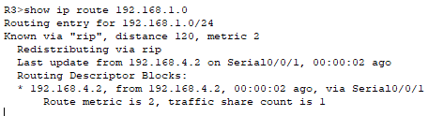

1. What is the default update time for RIP? 30 seconds

### Step 7: Configure your router to stop sending updates out the FastEthernet0/0 interface

Sending updates out this interface wastes the bandwidth and processing resources of all devices on the LAN. In addition, advertising updates on a broadcast network is a security risk. RIP updates can be intercepted with packet sniffing software. Routing updates can be modified and sent back to the router, corrupting the router table with false metrics that misdirects traffic.

The **passive-interface fastethernet 0/0** command in routing configuration mode is used to disable sending RIPv1 updates out that interface.

Router(config-router)#**passive-interface fastethernet 0/0**

### Step 8: Verify that updates are not sent to interface FastEthernet0/0 anymore

You can use **show ip protocols** to ensure FastEthernet0/0 is passive. You can also **use debug ip rip** to ensure that router is not sending any RIP updates to FastEthernet0/0

**Note:** Sometimes it is necessary to clear the dynamic routing table. Try the command Router # clear ip route *

on both R1 and R2 (you can also do it on the R3). This command will cause the routers to immediately

flush routes in the routing table and request updates from each other.

## Task: Clean Up

Erase the configurations and disconnect attached cabling

**Lab 5B- Configure and Verify OSPF Routing**

**Addressing Table:**

|  |  |  |  |  |
| --- | --- | --- | --- | --- |
| **Device** | **Interface** | **IP Address** | **Subnet Mask** | **Default Gateway** |
| R1 | F0/0 | 10.10.1.1 | 255.255.255.0 | N/A |
| S0/0/0 | 10.10.2.1 | 255.255.255.0 | N/A |
| R2 | S0/0/0 | 10.10.2.2 | 255.255.255.0 | N/A |
| S0/0/1 | 10.10.3.1 | 255.255.255.0 | N/A |
| R3 | S0/0/0 | 10.10.3.2 | 255.255.255.0 | N/A |
| S0/0/1 | 10.10.5.2 | 255.255.255.0 | N/A |
| F0/0 | 10.10.4.1 | 255.255.255.0 | N/A |
| R4 | S0/0/0 | 10.10.5.1 | 255.255.255.0 | N/A |
| S0/0/1 | 10.10.6.2 | 255.255.255.0 | N/A |
| R5 | S0/0/0 | 10.10.6.1 | 255.255.255.0 | N/A |
| F0/0 | 10.10.7.1 | 255.255.255.0 | N/A |
| PC1 | NIC | 10.10.1.2 | 255.255.255.0 | 10.10.1.1 |
| PC2 | NIC | 10.10.4.2 | 255.255.255.0 | 10.10.4.1 |
| PC3 | NIC | 10.10.7.2 | 255.255.255.0 | 10.10.7.1 |

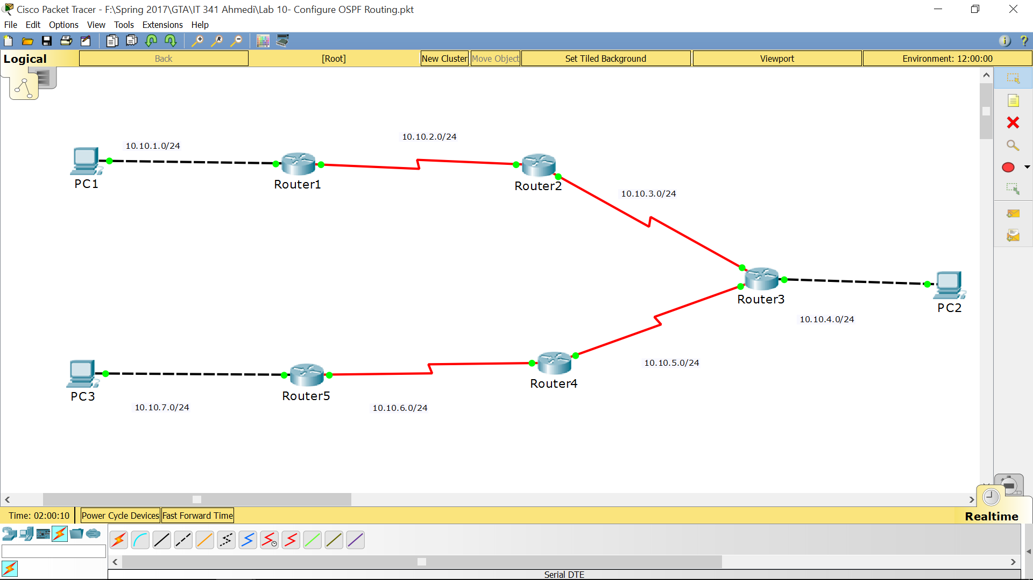

**Introduction:**

In this lab activity, you will use the topology for this chapter. OSPF routing will be used as the routing protocol. OSPF **area ID of 0 and process ID of 1** will be used in all OSPF configurations. The IP addressing is already configured.

### Task 1: Verify connectivity to next hop device. – 10points

You should NOT have connectivity between end devices yet. However, you can test connectivity between two routers and between an end device and its default gateway.

#### **Step 1.** Verify that the R1, R2, R3, R4 and R5 can ping each of the neighbouring routers.

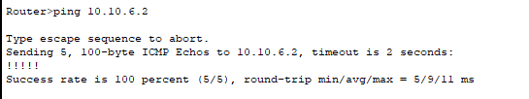

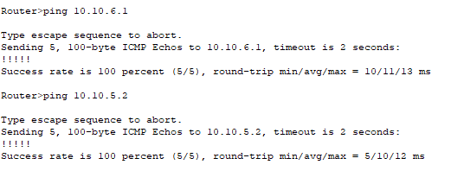

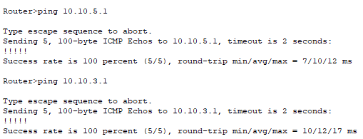

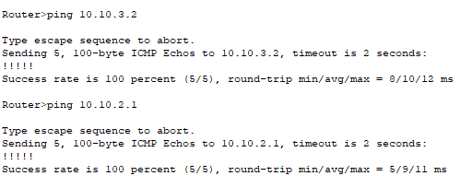

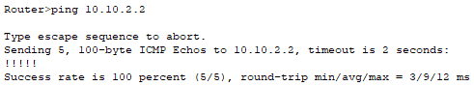

#### **Step 2**. Verify that PC1, PC2, and PC3 can ping their respective default gateway.

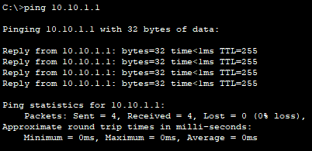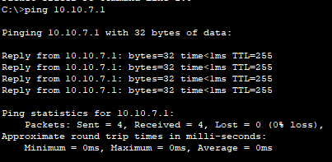

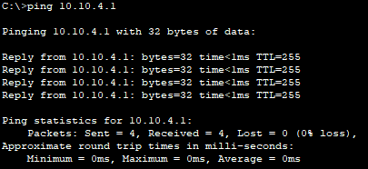

### Task 2: Configure OSPF routing on the R1 router. – 10points

#### **Step 1**. Consider the networks that need to be included in the OSPF updates that are sent out by the R1 router.

1. What directly connected networks are present in the R1 routing table?
2. What commands are required to enable OSPF and include the connected networks in the routing updates?
3. Are there any router interfaces that do not need to send OSPF updates?
4. What command is used to disable OSPF updates on these interfaces?
5. Configure OSPF routing on router R1 and disable OSPF updates on the appropriate interface(s).

R1(config)#**router ospf** *process_ID*

R1(config-router)#**network** *network_number wild_card_bits* **area** *area_ID*

R1(config-router)#**passive-interface** *interface_type interface_number*

### Task 3: Configure OSPF routing on the R2 router. – 10 points

#### **Step 1**. Consider the networks that need to be included in the OSPF updates that are sent out by the R2 router.

1. What directly connected networks are present in the R2 routing table?



1. Are there any router interfaces that do not need to send OSPF updates?
2. Configure OSPF routing and disable OSPF updates on the appropriate interface(s).

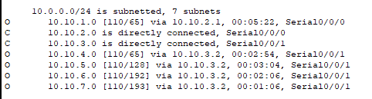

### Task 4: Configure OSPF routing on the R3, R4 and R5 routers and disable OSPF updates on the appropriate interfaces. – 10points

### Task 5: Verify the configurations. – 10points

Answer the following questions to verify that the network is operating as expected.

* From PC1, is it possible to ping PC2?
* From PC1, is it possible to ping PC3?

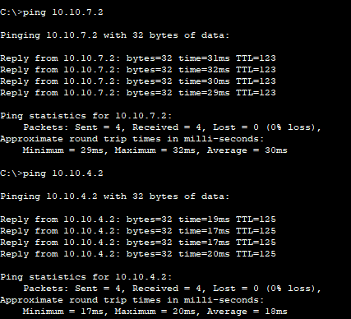

The answers to the above questions should be ‘yes’. If either of the above pings failed, check your configurations.

1. What OSPF routes are present in the routing table of the R1 router?
2. What OSPF routes are present in the routing table of the R2 router?
3. What OSPF routes are present in the routing table of the R3 router?
4. Issue the show ip protocols command on each router.
5. What is the router ID of each router?
6. Is each router routing its directly connected networks?
7. Which routers are listed as sources for routing information?